COMPONENTS OF STL

## **CONTAINERS**

Containers can be described as the objects that hold the data of the same type. Containers are used to implement different data structures for example arrays, list, trees, etc.

**Classification of containers :**

* Sequence containers
* Associative containers
* Derived containers

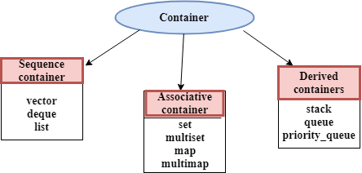

## **ITERATOR**

* Iterators are pointer-like entities used to access the individual elements in a container.
* Iterators are moved sequentially from one element to another element. This process is known as iterating through a container.

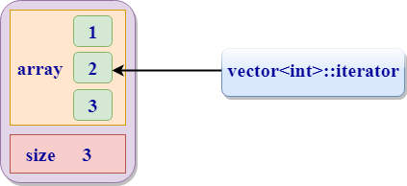

# C++ Vector

A vector is a sequence container class that implements dynamic array, means size automatically changes when appending elements. A vector stores the elements in contiguous memory locations and allocates the memory as needed at run time.

# C++ Deque

Deque stands for double ended queue. It generalizes the queue data structure i.e insertion and deletion can be performed from both the ends either front or back.

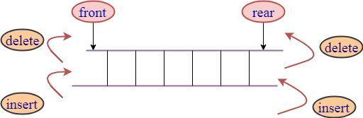

C++ List

* List is a contiguous container while vector is a non-contiguous container i.e list stores the elements on a contiguous memory and vector stores on a non-contiguous memory.
* Insertion and deletion in the middle of the vector is very costly as it takes lot of time in shifting all the elements. Linklist overcome this problem and it is implemented using list container.

# C++ STL Set

Sets are the associative containers that stores sorted key, in which each key is unique and it can be inserted or deleted but cannot be altered.

# C++ stack

This data structure works on the LIFO technique, where LIFO stands for Last In First Out. The element which was first inserted will be extracted at the end and so on. There is an element called as 'top' which is the element at the upper most position. All the insertion and deletion operations are made at the top element itself in the stack.

# C++ queue

# This data structure works on the FIFO technique, where FIFO stands for First In First Out. The element which was first inserted will be extracted at the first and so on.

# Priority Queue in C++

The priority queue in C++ is a derived container in STL that considers only the highest priority element. The queue follows the FIFO policy while priority queue pops the elements based on the priority, i.e., the highest priority element is popped first.

# C++ map function

Maps are part of the C++ STL (Standard Template Library). Maps are the associative containers that store sorted key-value pair, in which each key is unique and it can be inserted or deleted but cannot be altered. Values associated with keys can be changed.

# C++ multimap

**Multimaps** are part of the **C++ STL (Standard Template Library)**. Multimaps are the associative containers like map that stores sorted key-value pair, but unlike maps which store only unique keys, **multimap can have duplicate keys**. By default it uses < operator to compare the keys.